What the symbols mean (from the image)
- $y_{i}$→ actual value
- ${\hat{y}}_{i}$→ predicted value
- Error / residual = $y_{i}-{\hat{y}}_{i}$

MAE (Mean Absolute Error) — right side, top
$$\text{MAE}=\frac{1}{n}\sum_{i=1}^{n}{∣}y_{i}-{\hat{y}}_{i}∣$$
What the image shows:
- Absolute vertical distance between actual and predicted point
- Straight-line distance
✅ Advantage (written in image)
- Robust to outliers
- Not differentiable at 0
- Difficult to optimize mathematically
👉 That’s why MAE is not used as a cost function in ordinary linear regression

MSE (Mean Squared Error) — right side, bottom
$$\text{MSE}=\frac{1}{n}\sum_{i=1}^{n}{(}y_{i}-{\hat{y}}_{i})^{2}$$
What the image shows:
- Squared vertical distances
- Larger errors become much larger due to squaring
- Parabola shape (U-curve)

Why MSE is preferred (key exam concept)
✅ Advantage (circled “function” in image)
- Differentiable everywhere
- Smooth curve
- Easy to optimize using calculus (gradient descent)
❌ Disadvantage
- Not robust to outliers
- Large errors dominate the loss

RMSE formula (what’s shown)
$$\text{RMSE}=\sqrt{\text{MSE}}=\sqrt{\frac{1}{n}\sum_{i=1}^{n}{(}y_{i}-{\hat{y}}_{i})^{2}}$$
So:
- First → square the errors
- Then → take the mean
- Finally → take the square root
👉 RMSE is just MSE in original units

Why do we take the square root? (main idea)
MSE has squared units:
- If $y$is in dollars → MSE is dollars²
- If $y$is in years → MSE is years²
❌ Hard to interpret
RMSE fixes this by:
- Bringing the error back to original units of y
- Making it easy to explain and compare

Benefit of RMSE (what “benefit” refers to in image)
✅ Benefits
- Same units as the dependent variable
- Easy interpretation
- Penalizes large errors (inherits MSE property)
- Commonly used for model evaluation
👉 Example:
RMSE = 5 means
On average, predictions are off by about 5 units

What R² means (top of board)
R² = Goodness of fit
It answers:
How well does the regression model explain the variation in the output?
Range:
$$0≤R^{2}≤1$$
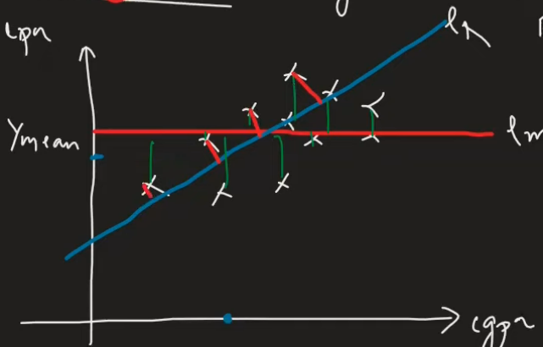
🔴 Red horizontal line → Mean model
$$\hat{y}=\overset{ˉ}{y}$$
- Predicts the mean for every input
- Baseline (worst useful model)
🔵 Blue slanted line → Regression model
$$\hat{y}=β_{0}+β_{1}x$$
- Actual fitted regression line
- Should reduce prediction error
Errors shown by vertical lines
- Green lines → errors from regression model
$$y_{i}-{\hat{y}}_{i}$$
- Red lines → errors from mean model
$$y_{i}-\overset{ˉ}{y}$$
The regression line has shorter errors, so it’s better than the mean.

R² formula
$$R^{2}=1-\frac{SS_{R}}{SS_{M}}$$
Where:
🔹 Residual Sum of Squares (SSR)
$$SS_{R}=\sum_{i=1}^{n}{(}y_{i}-{\hat{y}}_{i})^{2}$$
🔹 Total Sum of Squares (SSM)
$$SS_{M}=\sum_{i=1}^{n}{(}y_{i}-\overset{ˉ}{y})^{2}$$Intuition :
- If regression is perfect → $SS_{R}=0$
$$R^{2}=1$$
- If regression is no better than mean → $SS_{R}=SS_{M}$
$$R^{2}=0$$
👉 R² measures how much error is reduced compared to the mean model
Interpretation example:
- $R^{2}=0.80$
→ 80% of the variation in y is explained by x
- $R^{2}=0.00$
→ Model explains nothing beyond the mean

